Field Training Officer School | - CILETC  - March 28-30, 2022
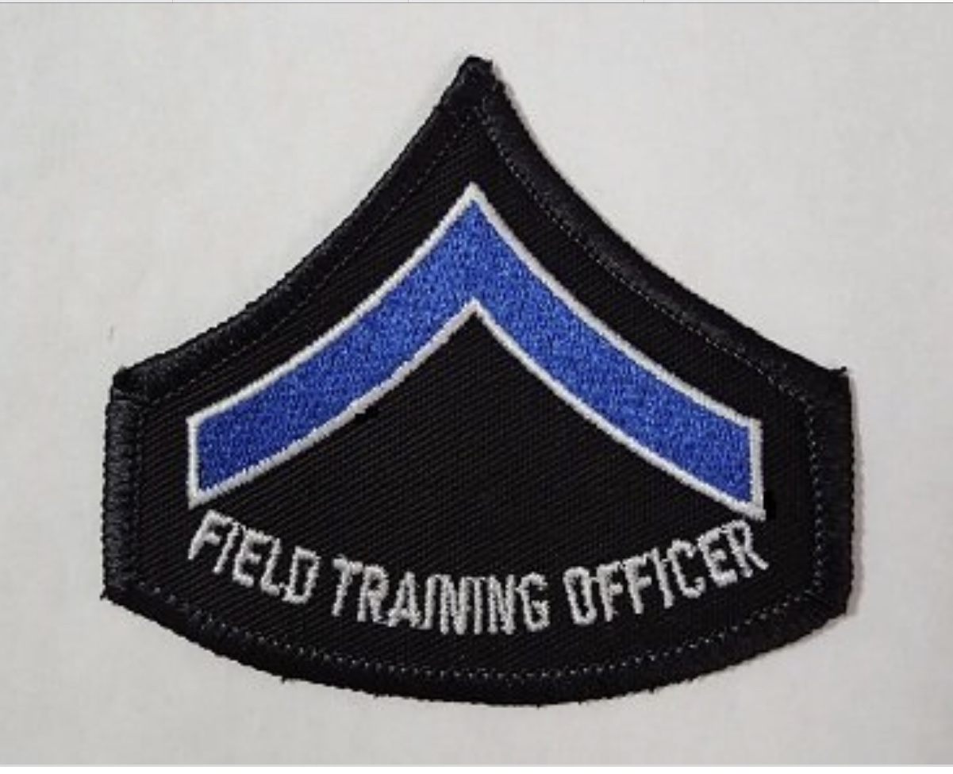  The Field Training Program: 3-day school  - Principles of leadership  - Laws and principles of learning  - Methods of instruction  - Liability issues  - Daily Observation Reports  - Understand performance evaluations  - Reasons for a field training program  - Role of the FTO  - Performance errors  - Effective communication  - Job-related appraisal system  - Standardized training to all recruits  - Produce highly trained employees | Location:  6210 Veterans Dr.  Whitestown, IN 46075  Instructor:  Sgt. Steve Kleeman  Evansville Police Department  ILEA Master Instructor  NAFTO Master FTO  PSID#2411-6049-2771-Master,F,E  skleeman@evansvillepolice.com

